Ideation Phase
Empathize & Discover

Date | 27 December 2025
Team ID | 4967
Project Name | Freelance Finder
Maximum Marks | 4 Marks

Empathy Map Canvas:
Understand the needs, frustrations, and behaviors of book lovers in India seeking an easy, affordable, and enjoyable online bookstore experience.

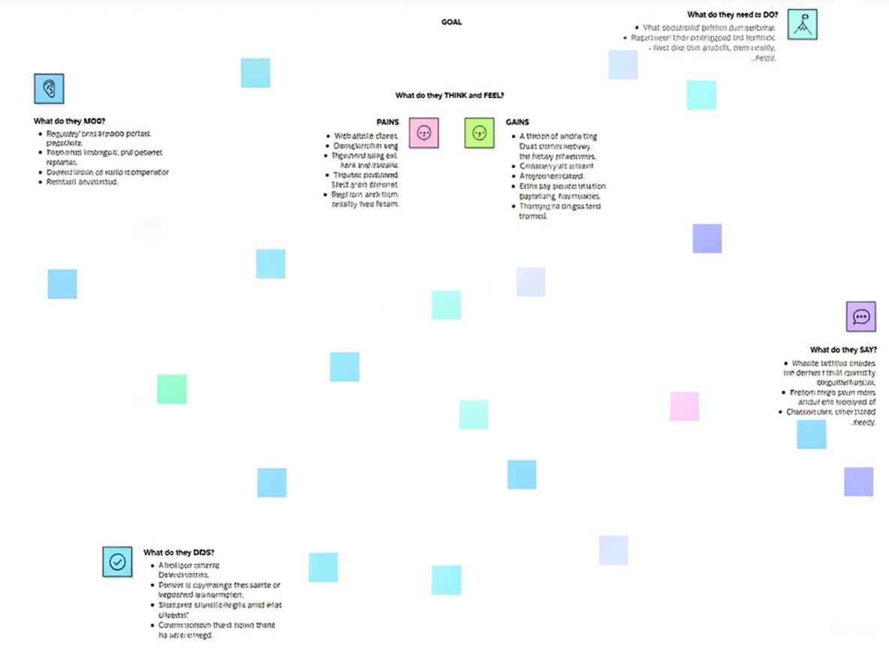

Reference: https://www.mural.co/templates/empathy-map-canvas

